**Project 1: -**

* **Deploying a web server in Windows instance.**
* **IP:** <http://18.223.134.170/>

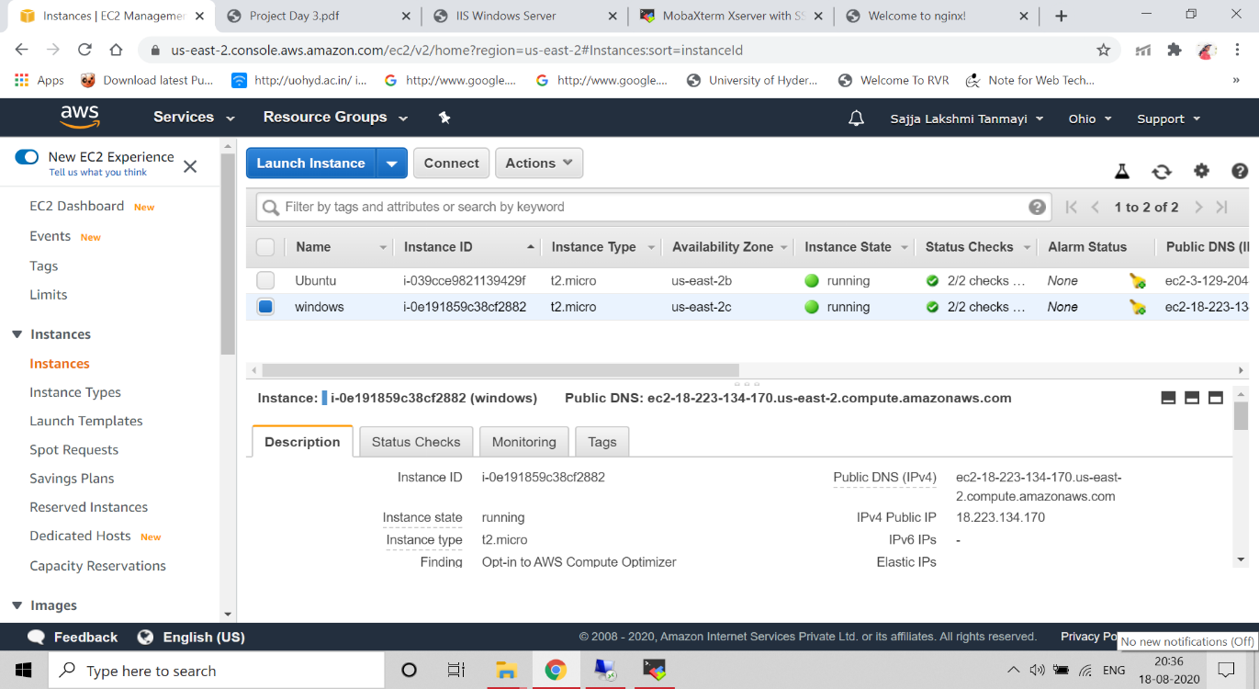

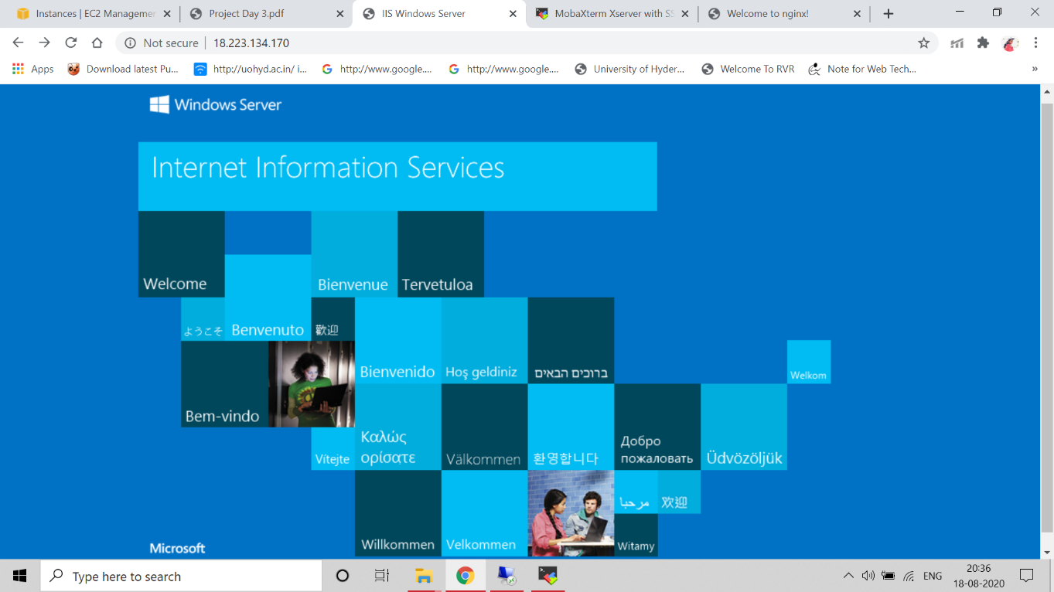

**Project 2: -**

* **Deploying a web server in ubuntu instance.**
* **IP:** <http://3.129.204.225/>

